http://www.12sky2-ph.com/web/media/list.aspx?DIV=artwork

[](http://www.12sky2-ph.com/)

**[news](http://www.12sky2-ph.com/web/news/announcement.aspx) Tin tức**

* [Announcements](http://www.12sky2-ph.com/web/news/announcement.aspx)
* [Notice](http://www.12sky2-ph.com/web/news/notice.aspx)

**[guide](http://www.12sky2-ph.com/web/guide/story.aspx) Hướng dẫn Game**

* [Story](http://www.12sky2-ph.com/web/guide/story.aspx)
* [Introduction](http://www.12sky2-ph.com/web/guide/Introduction.aspx)
* [Game Feature](http://www.12sky2-ph.com/web/guide/feature.aspx)
* [System Requirements](http://www.12sky2-ph.com/web/guide/requirements.aspx)
* [General Questions](http://www.12sky2-ph.com/web/guide/questions.aspx)
* [Getting Started](http://www.12sky2-ph.com/web/guide/start.aspx)
* [Class Info](http://www.12sky2-ph.com/web/guide/info.aspx)
* [Game Play](http://www.12sky2-ph.com/web/guide/play.aspx)
* [Pet Information](http://www.12sky2-ph.com/web/guide/pet.aspx)
* [Items](http://www.12sky2-ph.com/web/guide/item.aspx)
* [PvP Combat](http://www.12sky2-ph.com/web/guide/pvp.aspx)
* [Player Interaction](http://www.12sky2-ph.com/web/guide/player.aspx)
* [Government](http://www.12sky2-ph.com/web/guide/government.aspx)
* [NPCs](http://www.12sky2-ph.com/web/guide/npcs.aspx)

**[forums](http://www.12sky2-ph.com/web/community/list.aspx?DIV=discussion) Cộng đồng**

* [General Discussion](http://www.12sky2-ph.com/web/community/list.aspx?DIV=discussion)
* [Tips / Knowhow](http://www.12sky2-ph.com/web/community/list.aspx?DIV=tips)
* [Problem Solution](http://www.12sky2-ph.com/web/community/list.aspx?DIV=problem)
* [Item Trade](http://www.12sky2-ph.com/web/community/list.aspx?DIV=trade)

**[Media](http://www.12sky2-ph.com/web/media/video.aspx) Truyền thông**

* [Video](http://www.12sky2-ph.com/web/media/video.aspx)
* [Artwork](http://www.12sky2-ph.com/web/media/list.aspx?DIV=artwork)
* [Screenshots](http://www.12sky2-ph.com/web/media/list.aspx?DIV=screenshots)

**[Item Mall](http://www.12sky2-ph.com/web/shop/upgrading.aspx) Cửa hàng**

* [Item List](http://www.12sky2-ph.com/web/shop/upgrading.aspx)

**Media**

* [Video](http://www.12sky2-ph.com/web/media/video.aspx)
* [**Artwork**](http://www.12sky2-ph.com/web/media/list.aspx?DIV=artwork) Ảnh minh họa
* [Screenshots](http://www.12sky2-ph.com/web/media/list.aspx?DIV=screenshots) Ảnh chụp màn hình

Home > Media > Artwork

Artwork Ảnh minh họa

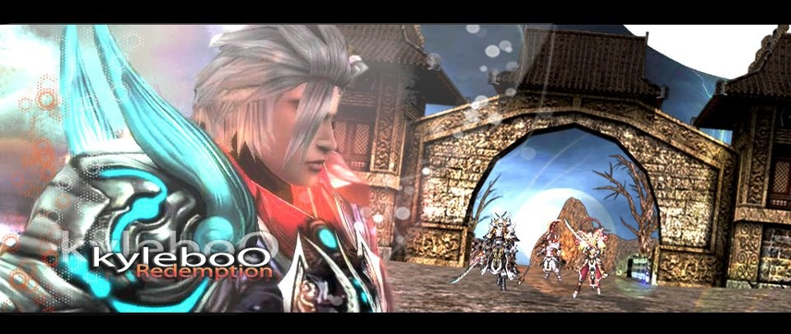

* [My Artwork](javascript:__doPostBack('LIST$ctl00$btn_list',''))

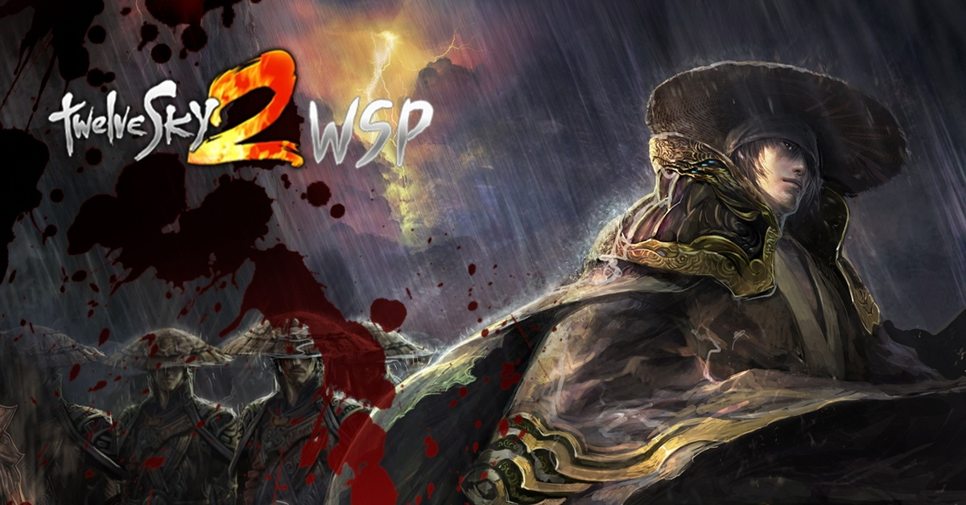

* [TwelveSky2 WSP 1 (1)](javascript:__doPostBack('LIST$ctl01$btn_list',''))

(1 / 1 Page )

[1](http://www.12sky2-ph.com/web/media/list.aspx?DIV=artwork)

[top](http://www.12sky2-ph.com/web/media/list.aspx?DIV=artwork)

KJ GAMESCopyright (c) KJ GAMES, All Rights Reserved.

* [Terms of Use](http://www.12sky2-ph.com/web/about/terms.aspx)
* [Privacy Policy](http://www.12sky2-ph.com/web/about/privacy.aspx)

양식의 맨 아래